ASSIGNMENT - 7.2

2303A510G1
Batch : 30

Task 1 – Runtime Error Due to Invalid Input Type
- A Python program accepts user input and performs arithmetic operations. However, the program throws a runtime error because the input is treated as a string instead of a numeric type.
Example (Buggy Code):
num = input("Enter a number: ") result = num + 10 print(result)
- Task:
Use AI tools to identify the cause of the runtime error and modify the program so it executes correctly.
Expected Output -1:
- AI converts the input to the appropriate numeric type and eliminates the runtime error.

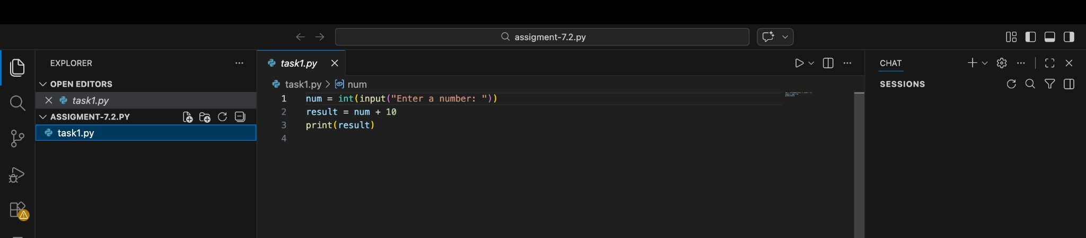

Output:

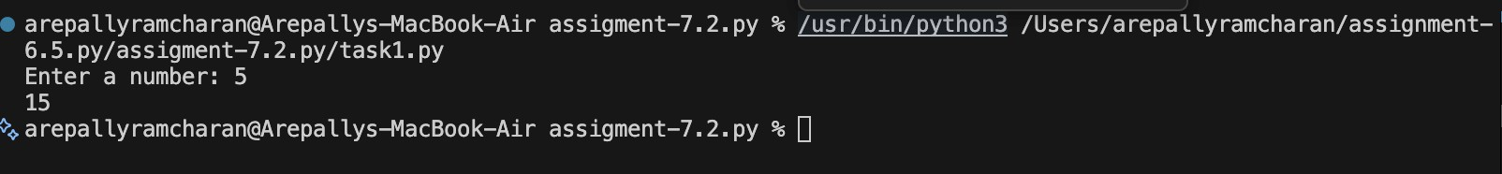

Observation:
The AI tool successfully identified the cause of the runtime error related to incorrect data types and corrected it by converting the input into a numeric type. This task demonstrates how AI-assisted code completion helps in debugging runtime errors, improves program reliability, and reinforces the importance of proper input handling in Python programs.

Task 2 – Incorrect Function Return Value
A function is designed to calculate the square of a number, but it does not return the computed result properly.
Example (Buggy Code): def square(n): result = n * n Task:
Use AI assistance to analyze the function and ensure the correct value is returned.
Expected Output -2:
AI fixes the missing return statement and the function returns the correct output.

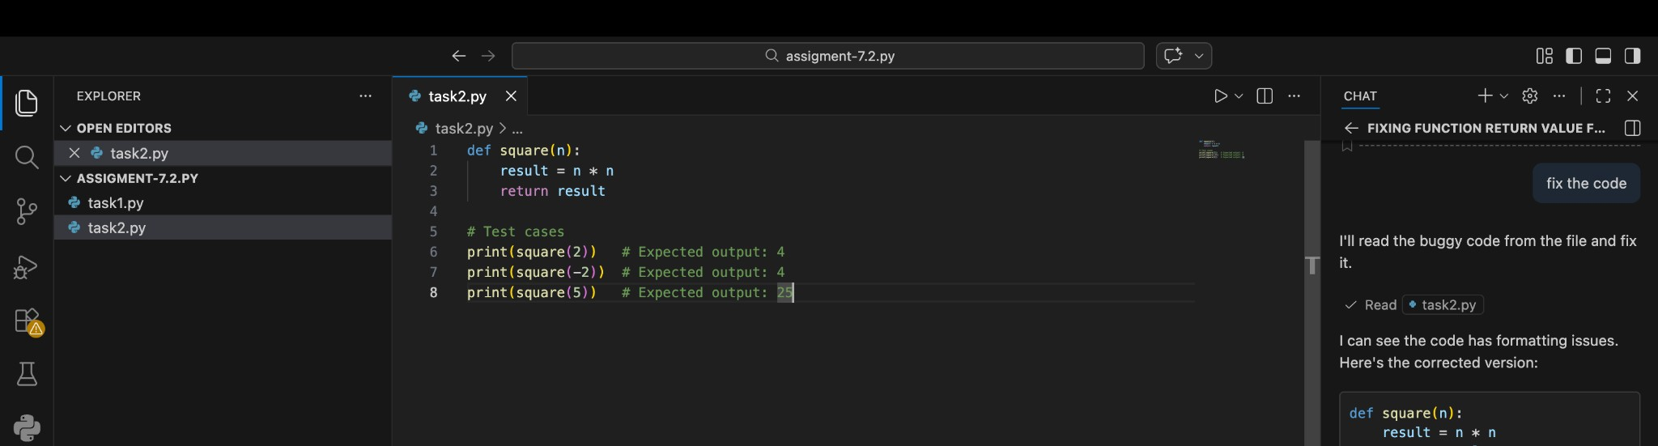

Output:

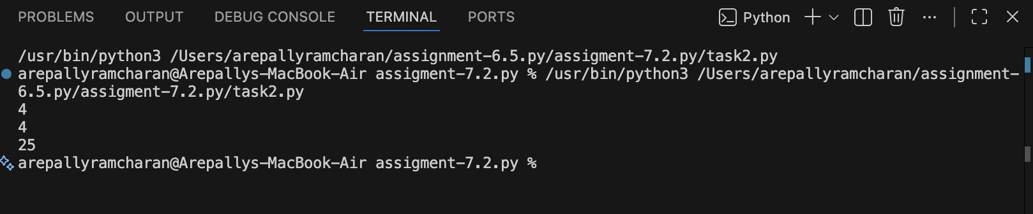

Observation:
The AI tool successfully identified the logical error caused by the missing return statement and corrected it. This task demonstrates how AI-assisted coding helps detect common function-related mistakes, improves code correctness, and reinforces the importance of returning values from functions in Python programs.

Task 3 – IndexError in List Traversal
A Python program iterates over a list using incorrect index limits, causing an IndexError. Example (Buggy Code): numbers = [10, 20, 30] for i in range(0, len(numbers)+1):
print(numbers[i])
Task:
Use AI to identify the incorrect loop boundary and correct the iteration logic.
Expected Output -3:
AI fixes the loop condition and prevents out-of-range list access.

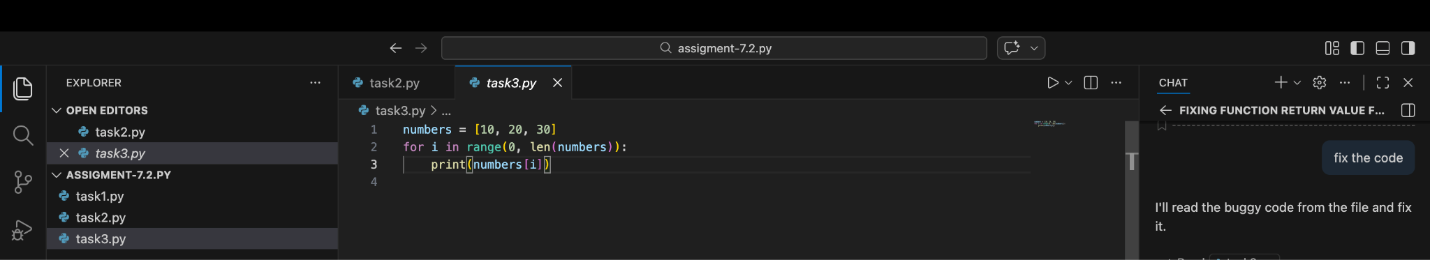

Output:
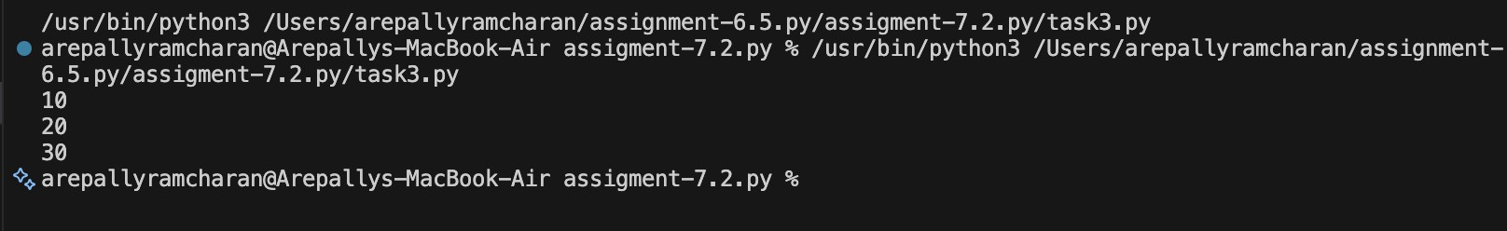
Observation:
The AI tool correctly detected the loop boundary error and fixed it by adjusting the iteration logic. This task highlights how AI-assisted debugging helps prevent common runtime errors, improves loop safety, and encourages best practices in list traversal.

Task 4 – Uninitialized Variable Usage
A program uses a variable in a calculation before assigning it any value.
Example (Buggy Code):
if True:
pass
print(total)
Task:
Use AI tools to detect the uninitialized variable and correct the program.
Expected Output -4:
AI initializes the variable correctly before it is used
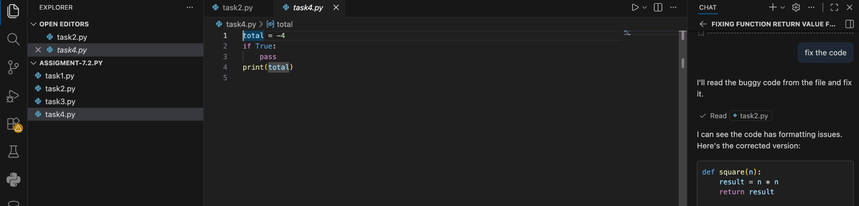

Output:
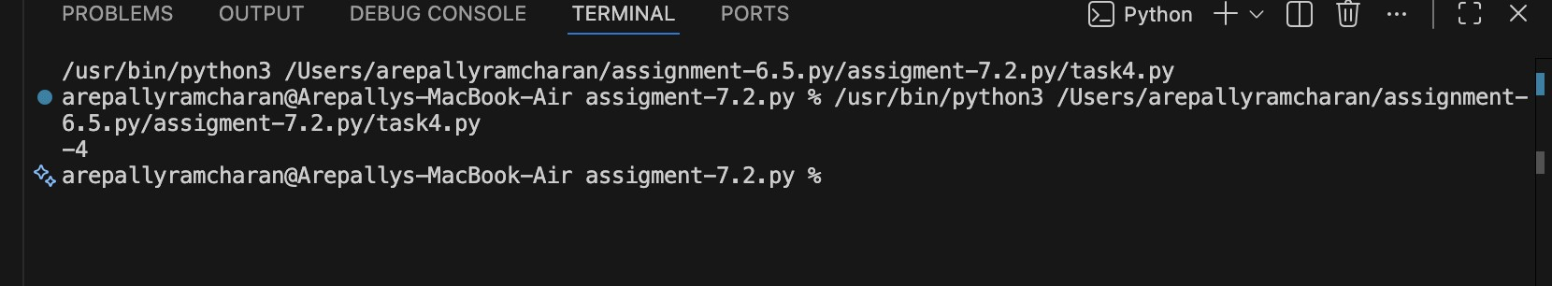

Observation:
The AI tool successfully detected the uninitialized variable and corrected the program by initializing it before use. This task demonstrates how AI-assisted debugging helps identify scope and initialization issues, improves program stability, and reinforces good programming practices.

Task 5 – Logical Error in Student Grading System
A grading program assigns incorrect grades due to improper conditional
logic.
Example (Buggy Code):
marks = 85 if marks >= 90: grade = "A" elif marks >= 80:
grade = "C" else:
grade = "B" print(grade)
Task:
Use AI to analyze the grading conditions and correct the logical flow.
Expected Output -5:
AI corrects the conditional logic so grades are assigned accurately.

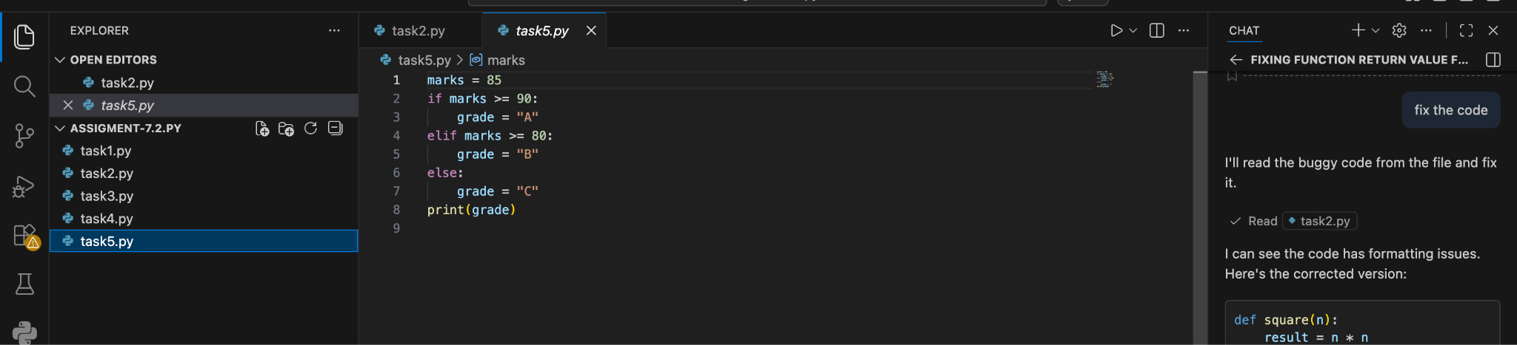

Output:
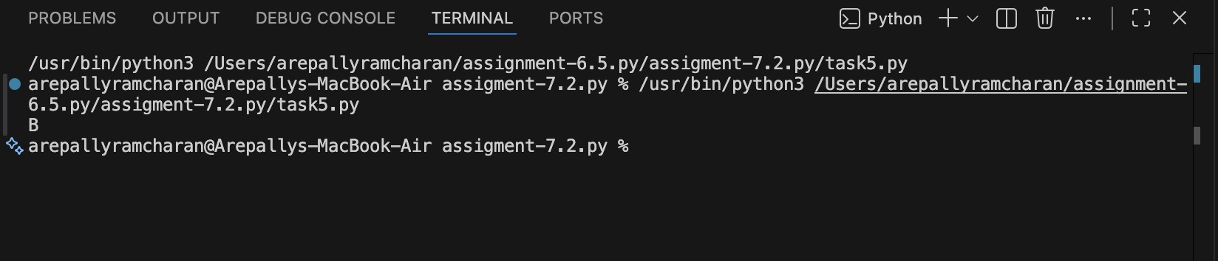
Observation:
The AI tool successfully identified the logical flaw in the grading conditions and corrected the conditional flow. This task demonstrates how AI-assisted code analysis helps detect logical errors, improves decision-making accuracy, and ensures program correctness

